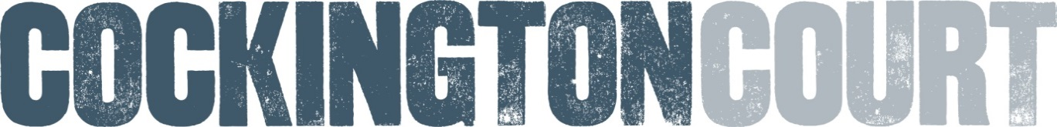

Sculpture Trail 2022
Application Form
This form is to be considered for selection for participation in the Sculpture Trail to be held at Cockington Court, 30th July – 31st October 2022. This year the theme of the Trail will be ‘Insects’.
Please read the information sheet before completing this form.
Once completed please return the application form electronically via email to Marissa.Wakefield@tda.uk.net. Deadline 17th April 2022.
A selection panel will be made up of curator/organisers Phil Dixon and Marissa Wakefield and other creative professionals. The decision will be final and all successful artists will hear by 24th April 2022. The panel may contact you prior to this date with questions.
Please send images of your completed work you would like to exhibit, or sketches suggesting work that you are proposing to create in time to exhibit.
All mediums are welcomed but please be aware we have limited indoor space for those non weatherproof artworks.
Name :
Address :
Mobile:

Landline:

Email:
Social Media :

Website:
Artist’s C.V.

Including any
relevant training, qualifications, exhibitions, commissions and collections.

Artist’s
Statement

(What inspires you, what mediums you like to use).
Examples Of Work  To support your artist’s CV please send between 1-5 jpeg images of past work, listing materials and dimensions.  If you have a website you can use this to describe up to 5 pieces on it. |  | 1  2  3  4  5
Work To Be Considered  Please either attach up to 6  J peg images of readymade and current work to be considered for our 2022 trail.  OR  These can also be photos or sketches of proposed future work.  Please number, title and list medium and dimensions. | 1  2  3  4  5  6

Please Note;
All work exhibited will be the responsibility of the artist throughout the duration of the Sculpture Trail and whilst on site. This includes delivery, installation, maintenance and then collection of work.
All artists who are successful in their applications to take part, will be required to pay a fee of £20.00 to contribute to the organising of the Sculpture Trail 2022. This will be payable upon the day of delivery and installation of sculptures on site.
Cockington Court has insurance which covers Public Liability but artists must consider health and safety in the art work created.
Work exhibited can be advertised for sale but a 30% commission is taken on all sales to support future trails.
Please return application forms electronically to Marissa.Wakefield@tda.uk.net by 17th April 2022 .
Telephone: 01803 607230
Website: www.cockingtoncourt.org
Address: Cockington Court Craft Centre, Cockington, Torquay, TQ2 6XA

Feijoa Project c.i.c

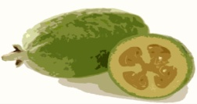
Growing - Propagating - Living

